MUJTABA SHAHID FAIZI

BSCS-5A

131818

LAB 6

TASK 1:-

</head>

<body>

<form>

<h1>Currency Convertor</h1>

Pakistan Rupees : <input type="text" id="pk" onKeyPress="conversion()" />

<br><br>

Currency:

<select id="option">

<option value="GB">GB</option>

<option value="USD">USD</option>

<option value="Euro">Euro</option>

</select>

<br>

<br>

</form>

<p>The Result is : <br>

<p id = "result"></p>

</p>

</body>

<script>

function conversion()

{

a = document.getElementById("option").value;

b = document.getElementById("pk").value;

if(a=="GB"){

document.getElementById("result").innerHTML = b * 0.0075;}

else if(a=="USD"){

document.getElementById("result").innerHTML = b * 0.0095;}

else if(a=="Euro"){

document.getElementById("result").innerHTML = b * 0.0089;}

}

</script>

</html>

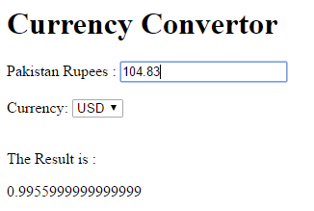

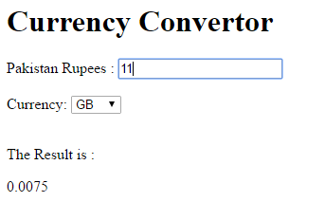

TASK 2:-

</head>

<body>

<form>

<h1>Password</h1>

Enter your password : <input type="text" id="p" onKeyPress="conversion()" />

<br><br>

<br>

<br>

</form>

<p>The Result is : <br>

<p id = "result"></p>

</p>

</body>

<script>

function conversion()

{

b = document.getElementById("p").value;

res=0;

if (b.match(/[1-9]/g)){

res++;

}

if(b.length>7){

res++;}

if (b.match(/[A-Z]/g) && b.match(/[a-z]/g){

res++;

}

if(b.match(/[*!@#$%^&()_+=]/g)){

res++;

}

if(res==0 || res==1){

document.getElementById("result").innerHTML = "bad";}

}if (res==2){document.getElementById("result").innerHTML = "poor";}

if(res==3){document.getElementById("result").innerHTML = "good";}

if(res==4){document.getElementById("result").innerHTML = "strong";}

}

</script>

</html>

By using javascript, I have used ids to be used in different functions like asking for input and storing values in variables. I have also used conditions to see which option is picked and then generated the output accordingly.